**Comparing profitability of playing Masters Tour events in 2022 and 2021**

*by Oldřich Mahdal (Faeli42)*

**Introduction** **1**

**Data** **1**

**Results** **2**

Difference for weaker players 2

Difference for stronger players 3

**Conclusion** **4**

# Introduction

I recently created an app showing your expected value (EV) for a single Masters Tour (MT) event based on your MT winrate (<https://twitter.com/Faeli42/status/1471752413988245512>).  
Based on the recent announcement about 2022 season (see rules: <https://bnetcmsus-a.akamaihd.net/cms/gallery/my/MYYLRQ4KS94R1639850538542.pdf>), I also created an updated version since the prize money distribution has changed. You can get the new one here: <https://drive.google.com/file/d/1UV5aItsgI__M2uj-62WgsnYlqXZP_ud9/view?usp=sharing>

Having the ability to compute EV for previous seasons as well as the new season, let us compare and analyze. Note that EV always calculates with 1 MT cash prizes only.

# Data

Using my app I was able to get EV values for the new system (2022) as well as the previous one (2021). Note that we always calculate with 400 players, 8 rounds, no drops:

| WINRATE | 0 | 5 | 10 | 15 | 20 | 25 | 30 | 35 | 40 | 45 | 50 | 55 |
| --- | --- | --- | --- | --- | --- | --- | --- | --- | --- | --- | --- | --- |
| 2021 EV (old app) | 0,0 | 0,1 | 1,5 | 7,0 | 20,4 | 45,9 | 88,6 | 154,7 | 253,9 | 401,7 | 625,0 | 967,6 |
| 2022 EV (new app) | 0,0 | 0,2 | 2,9 | 12,4 | 33,6 | 70,5 | 126,4 | 204,1 | 307,4 | 443,4 | 625,0 | 874,6 |

| WINRATE | 60 | 65 | 70 | 75 | 80 | 85 | 90 | 95 | 100 |
| --- | --- | --- | --- | --- | --- | --- | --- | --- | --- |
| 2021 EV (old app) | 1498,8 | 2319,9 | 3569,1 | 5416,2 | 8039,2 | 11566,1 | 15960,0 | 20812,6 | 25000,0 |
| 2022 EV (new app) | 1228,0 | 1738,1 | 2476,2 | 3528,8 | 4984,4 | 6902,9 | 9255,2 | 11818,4 | 14000,0 |

See full data here:

<https://docs.google.com/spreadsheets/d/1HHHPdVr3GPoo53XBTlway4sn8wRKOmzchiAKofFdJHI/edit?usp=sharing>

# Results

## Difference for weaker players

In this category we should realistically focus on players between 30-50% WR (if somebody has below 30% winrate, then winnings probably do not matter for them at all).

We can see an IMPROVEMENT in matters of 0-40% compared to previous distribution. This means that if your main goal is to qualify for a MT, but then your expectations are limited / you come to play mainly for fun and not results, you should be happy about the changes as you get more money along the way.

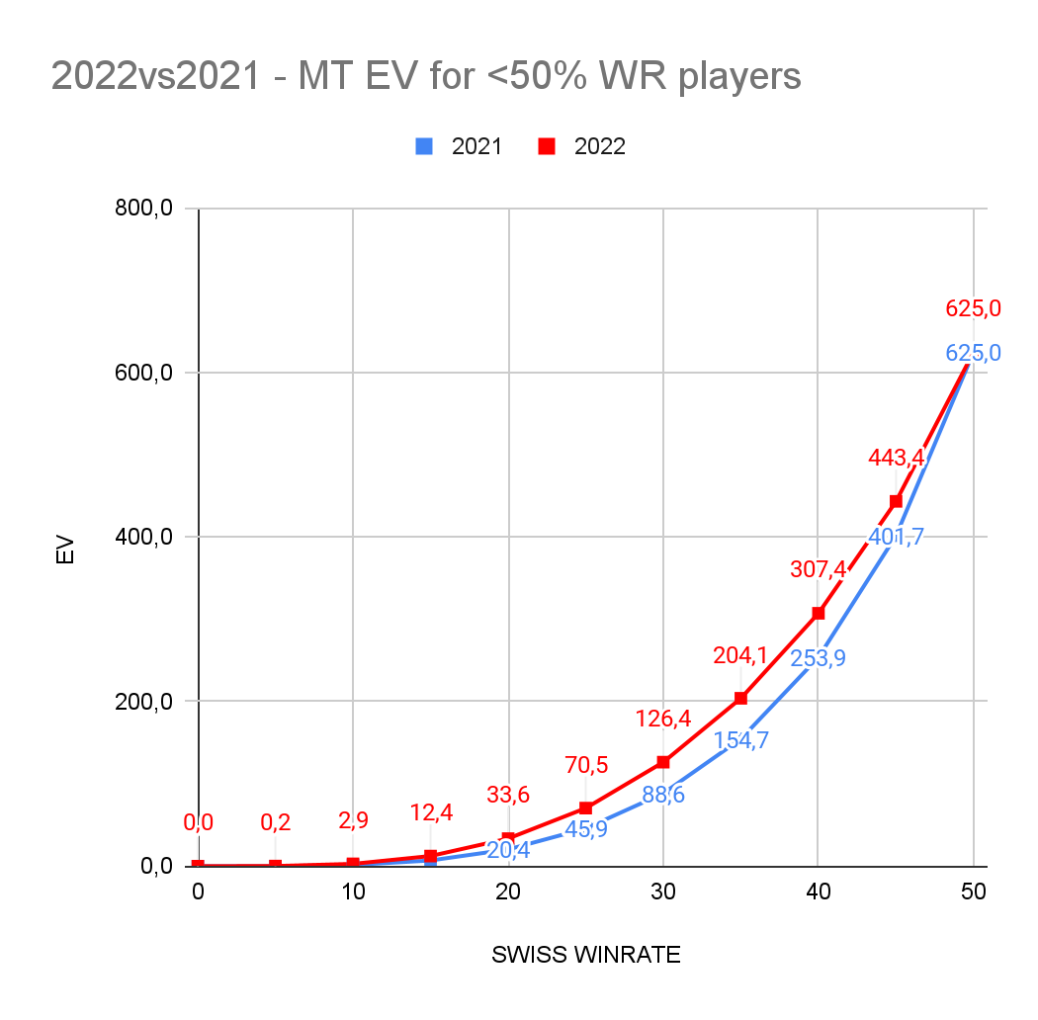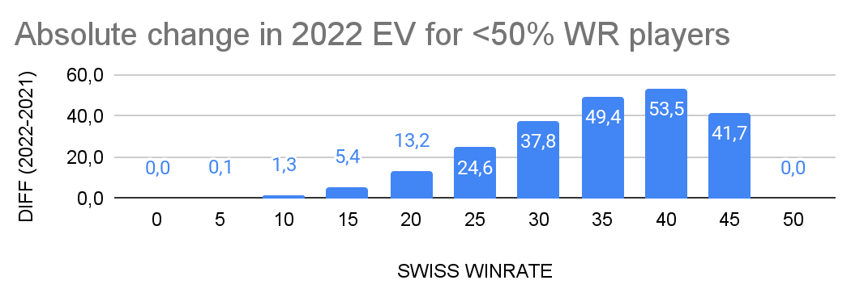

## Difference for stronger players

Even the very best of players have around 70% WR (in the long term), so that is the upper limit for our consideration here.

An obvious DECLINE can be seen for 2022. Looking at the graph we can see that the best players are effectively losing hundreds of $$$ each MT compared to the previous distribution. One of the obvious reasons is that these strong players are more likely to reach top16 where the prize cut is felt the most.

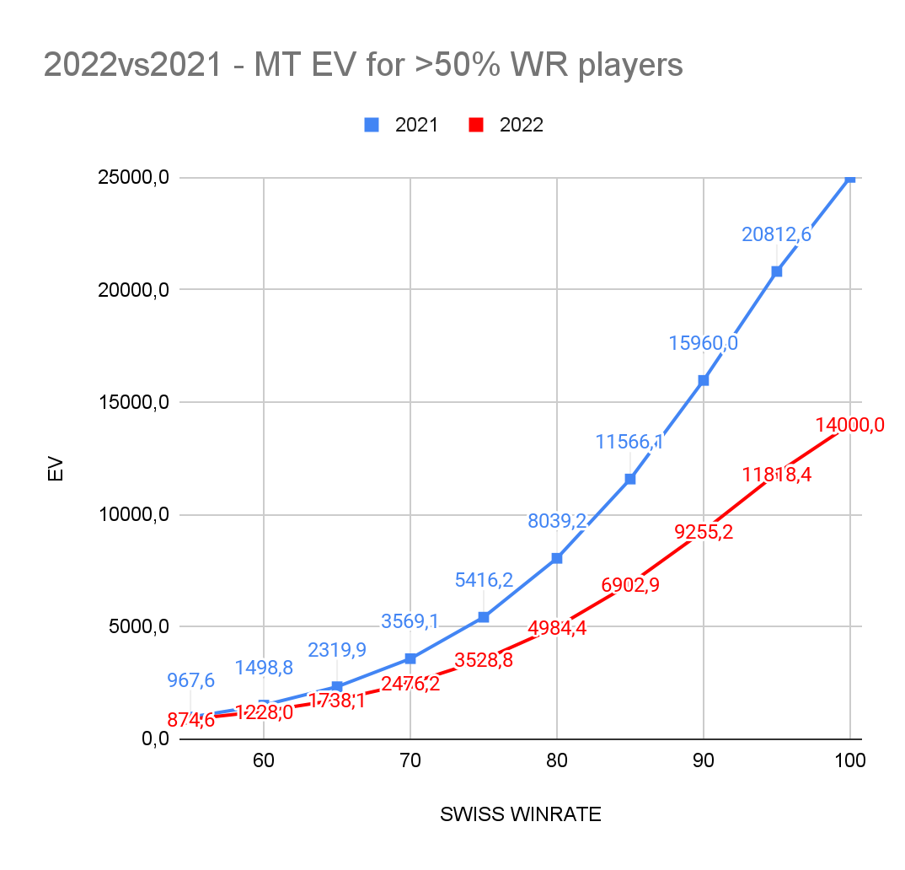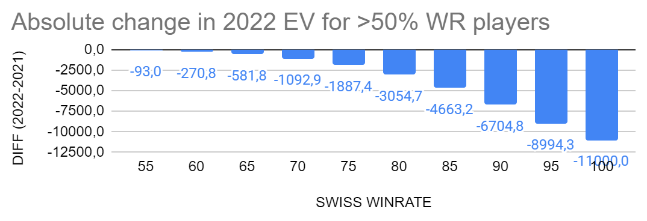

# Conclusions

From a GM point of view:

* Unfortunately GMs cannot be happy about these changes from the financial side, especially those who entered the elite recently will not be getting that nice chance to earn their deserved money in the long term. On the other hand, GMs will now be more forced to actually participate in MTs and other events for which they can be rewarded better than before.
* Overall slightly negative.

From a competitive non-GM point of view:

* While every MT now effectively grants you less money, there is an added value of being able to play the seasonal championships as well as to qualify for worlds. This fact is then lessened by the absence of GM promotion which was the ultimate reward for performing well.
* Overall slightly negative (?).

From a “casual” MT player point of view:

* While low winrate players probably do not have real chances of getting to seasonal championships and such, the main change is getting some extra money from MTs if you manage to qualify. No real downside.
* Overall slightly positive.

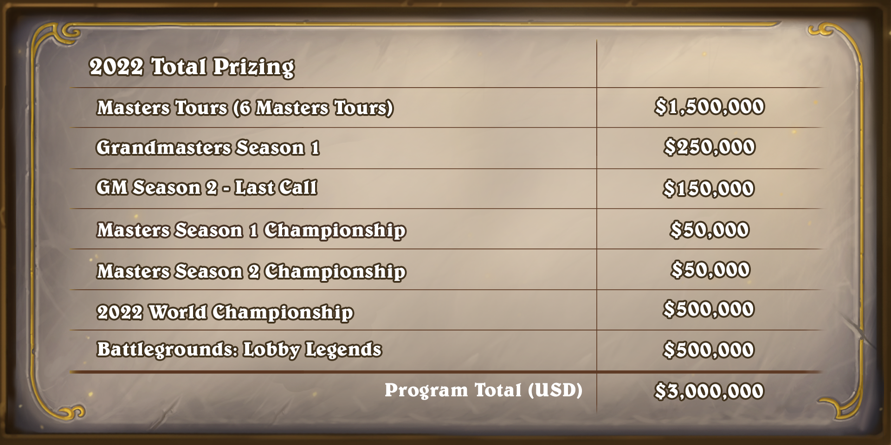

(source: <https://playhearthstone.com/en-us/news/23747034/hearthstone-esports-evolves-in-2022>)